Style Guide for Gimo Games

A Resource for Document Formatting

Gimo Games

Kyle Rollins and Spencer Stevens

Table of Contents

Table of Figures iii

Introduction iv

Part One: General Guidance 1

Grammar and Usage 2

1.1 Compound Adjectives 2

1.2 Compound Nouns 2

1.3 Proper Nouns 2

1.4 Parallel Structure 2

1.5 Dialect(s) 3

1.6 Subject-Verb Agreement 3

Punctuation 3

2.1 Semicolons 3

2.2 Commas 3

2.3 Hyphens, En Dashes, and Em Dashes 4

2.4 Apostrophes 4

Spelling 4

3.1 Commonly Misspelled and Confused Words 4

Sentence Structure 5

4.1 Dependent Clause 5

4.2 Independent Clause 5

4.3 Sentence Fragment 5

Names and Terms 5

5.1 Place Names 5

5.2 Characters 6

Geographical Terms 6

6.1 Real World Locations 6

6.2 Game Locations 6

Numbers 6

7.1 Dates 6

7.2 Large numbers 7

Part Two: Document Type Guidelines 8

Document Titles 8

8.1 Informational Documents. 9

8.2 Documents Pertaining to Game Mechanics 9

Game Mechanics Documents 10

9.1 Bestiary 10

9.2 Monster Moves 11

Game Story Documents 11

10.1 Quests 11

10.2 Storyline 12

10.3 Dialogue 14

Planning Documents 15

11.1 Task List 15

11.2 Art 15

# Table of Figures

Figure 1 Example of an informational document title 9

Figure 2 Example of a mechanical document title 9

Figure 3 Example of the bestiary document 10

Figure 4 Example of the Monster Moves document 11

Figure 5 Example of a quest entry 12

Figure 6 Example of quest entry formatting 12

Figure 7 Example of the storyline document 13

Figure 8 Example of quest entry in the storyline document 14

Figure 9 Example of dialogue 14

Figure 10 Example of the Task List document 15

Figure 11 Example of the Art document 16

# Introduction

Gimo Games is a young company with relatively few employees. In the interest of uniformity in writing, this style guide was created. Even with only a handful of people contributing to publications within and without Gimo Games, there can be a large disparity in formatting, consistency, and accuracy. This style guide addresses the issues of formatting, inconsistency, and accuracy, and establishes the company voice.

It is important that any publications that may find their way out of Gimo Games have the same voice. This unity of voice will contribute to Gimo Games’s image of a unified group of talented individuals who are striving to create quality products. Gimo Games wishes to present itself as professional and competent. This style guide will help employees achieve professionalism and competency in writing.

Gimo Games’s publications and documents rely heavily on two sources: *The* *Chicago Manual of Style 16th Edition* and Dictionary.com. This style guide follows many of the guidelines found in *The Chicago Manual of Style* and defers to Dictionary.com in matters of spelling and hyphenation. From this point on, *The Chicago Manual of Style* will be referred to as the *CMS*. If there is any dispute about the rules in this style guide, or a rule is not present, the reader is encouraged to research this style guide’s sources.

Please note that revisions and additions of this style guide will be frequent. As new needs arise within Gimo Games, they will be addressed in new versions of the style guide.

On behalf of Gimo Games  
Kyle Rollins and Steven Spencer  
Fall 2011

# Part One: General Guidance

## Grammar and Usage

### 1.1 Compound Adjectives

Also known as compound modifiers, these are words joined by one or more hyphens that describe another word.  Only use when describing another word; avoid putting in the hyphen when it appears as an adverb modifying something else.    
  
Ex. The half-baked cookie did not taste very good to me.

### 1.2 Compound Nouns

Compound Nouns:  Sometimes a noun can work in a sentence as an adjective, and in so doing it describes another noun.  Remember that just because some of these nouns end in *ing* does not mean that they are nouns acting as a state of being or a verb.    
  
Ex. I read the morning paper on a daily basis.

### 1.3 Proper Nouns

Proper nouns call specific attention to something, such as a title or a particular place of importance.  No other nouns should be capitalized, unless the author intends to call special attention to them.  Common nouns, by simple definition, are these simple nouns that do not require specific attention.    
  
Ex.  The monster jumped out from the closet, ready to scare the child in the bed.

### 1.4 Parallel Structure

When writing a document, the author should adhere to traditional rules of grammar, following the *CMS* when they have any questions.  This will lead to parallel structure within a document, meaning that style, organization, and other aspects of the document will remain the same consistently throughout its content.  This serves to clear any confusion on the part of the reader.

Ex.  Throughout their journey, the main characters *traveled* in many lands and *fought* much evil.

### 1.5 Dialect(s)

Because of the unique nature of the documents this company prepares, we recommend that they also adhere to the guidelines found in the *CMS* as to any dialects used.  Otherwise, the readability of the documents will decrease and they won’t be as clear.  Also, following such guidelines may also preserve the dialects used while also cleaning them up somewhat.

### 1.6 Subject-Verb Agreement

When writing any document, the author must recognize that subject-verb agreement must continuously exist.  It helps make the document simpler, and also serves to make it an easy reference for people in the company who want to go back and review its contents.

Ex.  The trains run on schedule (correct) vs.  The trains runs on schedule (incorrect).

## Punctuation

### 2.1 Semicolons

Semicolons separate independent clauses, and help clarify long sentences.  Semicolons should not be used more than once in a sentence, ideally, and only work when the phrases on either side can stand alone and make sense.   Sometimes they are also used before conjunctions.  
  
Ex. I failed to turn up for the exam; yet my teacher allowed me another chance to take it.

### 2.2 Commas

Commas are used to break up run-on sentences, create lists, and make breaks within sentences.  Do not use commas excessively, or place them in the improper places.  Doing so will slow down and possibly confuse the reader.  Always use the serial comma. The serial comma appears before the conjunction in a series of three or more items. The conjunction should join the last two items of the series.  
  
Ex.  When walking in Oz, Dorothy was afraid of lions, tigers, and bears.

### 

### 2.3 Hyphens, En Dashes, and Em Dashes

Hyphens are used to create compound adjectives and to separate numbers, such as phone numbers or ISBNs.  Additionally, if a word is spelled out letter by letter, use hyphens.  However, do not use hyphens to indicate the word *to* in numbered lists or to indicate an abrupt break in thought.  The first calls for an en dash and the second, an em dash.    
  
Ex.

Hyphen: My phone number is not 801-731-0000.

En Dash: I believe we need about 6 – 8 cups of flour.

Em Dash: You really have done a good job—but you could have done better.

### 2.4 Apostrophes

Apostrophes indicate possessiveness or shorten words into contractions.  Avoid slang uses of contractions, such as *ain’t*, unless appropriate for dialogue.  Also, in matters of possessiveness, always refer to the *CMS* if confused on how to form possessives.  Generally speaking, however, plurals use the apostrophe after the *s*, and singulars use it before.    
  
Ex.  My brother’s apartment is in Salt Lake City.

## Spelling

### 3.1 Commonly Misspelled and Confused Words

Many words are commonly misspelled, but we have decided to include only the most commonly misspelled ones.    
  
1. They’re, their, and there:  *They’re* means they are, *their* is used possessively, and *there* indicates location.  
2. You’re and your:  *You’re* means you are and *your* indicates possessiveness.   
3. It’s and its:  *It’s* refers to it is and *its* shows possessiveness.  
4. All ready, already:  *All ready* refers to the degree of preparation and *already* refers to time.  
5. Compliment, complement:  *Compliment* refers to a pleasant remark about something and *complement* means to enhance in quality.    
6. Ensure, insure:  *Ensure* means to make sure something happens and *insure* means to cover by insurance.  
7. Principle, principal:  A *principle* is an ethic or virtue and a *principal* is a type of administrator.    
8. Strait, straight:  A *strait* is a narrow body of water and *straight* can describe orientation.  
9. Are, our:  *Are* is a verb and our is a possessive pronoun.

## Sentence Structure

### 4.1 Dependent Clause

A dependent clause is a group of words that doesn’t stand alone by itself with a subject and a predicate.  Without another set of words, it does not make sense alone. In the following example, “will feel tired” is a dependent clause.  
  
Ex.  I am staying up late, and will feel tired.

### 4.2 Independent Clause

An independent clause is a group of words that can stand alone, having both a subject and a predicate.  It does not require another set of words to make sense. In the following example, “I occasionally took breaks to maintain my steady pace” is an independent clause.

Ex.  While typing my essay, I occasionally took breaks to maintain my steady pace.

### 4.3 Sentence Fragment

A sentence fragment is a sentence that lacks a subject, a predicate, or both.   
  
Ex.  Games are fun for many reasons. Such as flashy explosions.

## Names and Terms

### 5.1 Place Names

When talking of fictional places, the author must determine whether the particular place holds significance within the storyline.  If it is a general, common sort of place, then no capitalization or other emphasis is needed.  If it is an important place, such as a capital, then it should be capitalized.  This applies to informational and storyline documents.    
  
Ex.  Atlantis, a pretend city within a game, must be capitalized because it is special.

### 5.2 Characters

Because video games generally refer to main characters as people, we recommend treating these as proper nouns.  However, not all characters are main characters, and for more generic characters (such as fictitious creatures, perhaps) we would recommend treating them as common nouns.    
  
Ex.  Retah, a main character, requires capitalization.

### 

## Geographical Terms

### 6.1 Real World Locations

Depending on the type of real world location, rules will vary.  If the place is significant, such as a capital, it needs to be capitalized and, if the author wishes, otherwise emphasized.  That is the only time any emphasis is needed with these places.    
  
Ex. The author referred to Hong Kong, China in his document.

### 6.2 Game Locations

To maintain consistent formatting throughout documents, we recommend that game locations be capitalized according to the same rules applied to real world locations, characters, etc.  The documents will appear more aesthetically pleasing this way.    
  
Ex.  Hamunaptra is called the city of the dead, containing the wealth of Egypt.

## Numbers

### 7.1 Dates

Since most documents will remain unpublished, dates will spell out the month and use a numeral for the day and year.    
  
Ex.  My birthday is July 26, 1989.

### 7.2 Large numbers

Numbers one through nine are spelled out. Numbers greater than nine use numerals. For large numbers, this rule still applies, except only whole numbers are spelled out. For example, a whole number such as two hundred thousand is spelled out completely. But 147,510 is not a whole number, and should not be spelled out. Even larger numbers spell out one through ninety-nine followed by million, billion, etc. If the first sequence of numbers is greater than ninety-nine, then numerals are used, such as : 220 million.  
  
Ex.  I have nine cats, and one billion dogs.

# Part Two: Document Type Guidelines

## Document Titles

### 8.1 Informational Documents.

C:\Users\Kyle\Desktop\3.JPGAny document created as a reference for future use should have a title that reflects the document’s contents, including a parenthetical statement signifying the document as informational. Informational document titles should follow this format: topic idea (informational) – date. For example, a document detailing geographical locations in the game *Monster Guru* would be title something like Monster Guru Locations (informational) – 11/20/2011.

Figure Example of an informational document title

Clear document titles enable Gimo Games employees to quickly find what they need and see how relevant the information is. A six-year old document would likely be out-of-date and its information possibly misleading.

If a document is revised, the document’s title should be altered to reflect the date of the document’s update. Keeping track of this information can help Gimo Games employees at a later point in time.

### 8.2 Documents Pertaining to Game Mechanics

C:\Users\Kyle\Desktop\2.JPGDocuments of a more technical nature should bear titles similar to informational documents with the exception of the parenthetical statement. Instead of marking the document as informational, the parenthetical statement should indicate that the document relates to game mechanics. Mechanical document titles should follow this format: topic idea (mechanical) – date.

Figure Example of a mechanical document title

The reasoning behind labeling mechanical documents this way is the same as labeling informational documents with their titles. Clarity can help Gimo Games employees locate pertinent information more quickly. A date exhibiting the documents age is very important, as the information in the document may become outdated.

If a document is revised, the document’s title should be altered to reflect the date of the document’s update. Keeping track of this information can help Gimo Games employees at a later point in time.

## Game Mechanics Documents

### 9.1 Bestiary

#### 9.1a General

The Bestiary is a table with all of the Monsters in *Monster Guru*. Every Monster has different statistics, pictures, types, notes, and capture options. With so many details, this document can quickly become overwhelming if Gimo Games employees stray from the established guidelines. No one should add anymore columns to the document, unless that person has received permission to do so.

When a new creature is added to the Bestiary, it is important to make sure that permission has been granted to do so. The stats for the Monsters in this document form the basis for gameplay in *Monster Guru*; because of this, it is imperative that Gimo Games employees refrain from changing the Monster statistics unless expressly asked to do so.

Text within the document should contain complete sentences and follow the rules of grammar laid out in this style guide, *The Chicago Manual of Style*, and Dictionary.com.

#### 9.1b Formatting

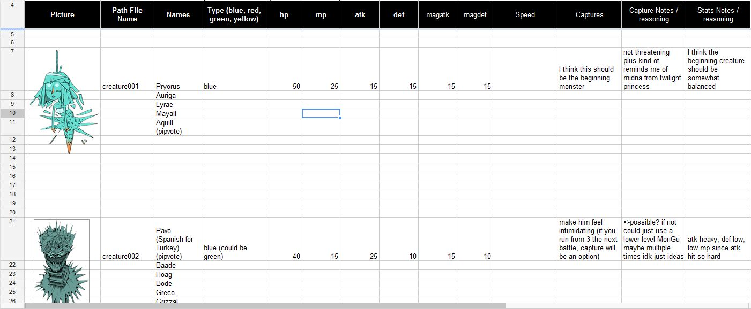The only columns that should appear in the bestiary are the following: Picture, Path File Name, Name, Type, hp, mp, atk, def, magatk, magdef, Speed, Capture Condition, Capture Notes, and Stats Notes. The columns should appear in the order presented. Notice that all column titles are capitalized except for the abbreviations, e.g. hp.

Figure Example of the bestiary document

Column titles should be center justified and placed in the middle of the box. The goal is to bring the column titles as closely to the center of the box as possible. The titles should be colored a light gray and the background should be black. These colors highlight the column titles, making it easy to determine which stat the reader is looking at.

All text within the document should be twelve-point Times New Roman.

### 9.2 Monster Moves

The Monster Moves table should be formatted so that every column is a different move type. The rows of the table should be the various Monster moves that fall under the column categories. Moves that are not yet assigned a type should be placed to the right of the table. For further formatting reference, refer to the image below.

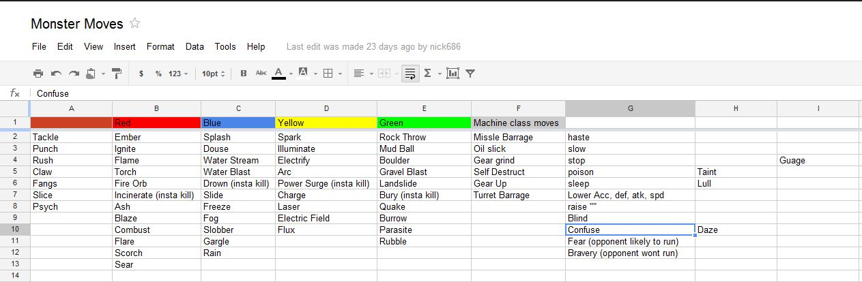

Figure Example of the Monster Moves document

While this table may seem cluttered with information at first, its purpose is to organize the different Monster moves in *Monster Guru* into a coherent and logical format. This table should be viewed as a reference source.

## Game Story Documents

### 10.1 Quests

Quests must be documented in a particular format. Each chapter is broken up by a heading with the title of the chapter.  Within each of these chapters each quest is given a number, name, quests unlocked on completion, an English description of the quest, bullets for events required to finish, bullets for other awards given (items, creatures, etc.) or effects that happen (disable an event).

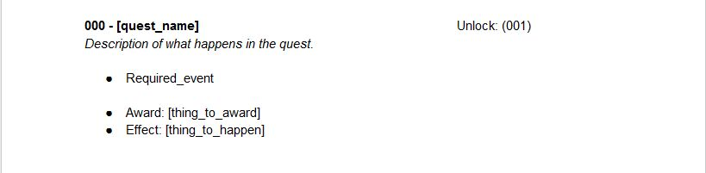

Figure Example of a quest entry

If a numbered list is used for the events, then those events must be done in order to finish the quest.  Nothing more complicated than either an unordered list or ordered list can be done in the scope of our game (in order to do something more complicated, must work within the constraints of this system.  For example: to do an either do this or that type mission, have quest a either quest b or c is completed it disables the other quest, and unlocks the quest unlock quest b and c, and when corresponding to the path desired in our scripting of quests).

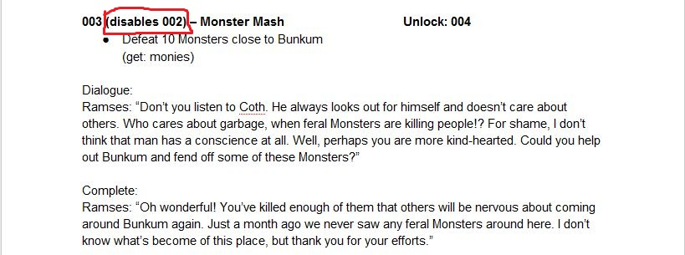

Figure Example of quest entry formatting

Remember, it is imperative that if a quest disables another quest, then that information is prominently displayed in the quest title.

### 10.2 Storyline

The storyline document should be formatted in a somewhat similar manner as the quests document. Each section of the document should have a title that tells the reader what the section deals with. There are two primary types of sections: scene and quest. Between these two types of sections, the storyline document lays out the progression of in-game events.

As depicted in the image below, scene sections should be titled in the following manner: Scene 000. The number is determined simply by chronological order. The title for a scene should be highlighted in orange for easy reference. Each scene section should have a short description followed by requirements for the scene, such as art, music, or SFX. Depending on the scene, there might be a description followed by requirements, then another description followed by requirements, and so on until the scene is complete. Requirements should be bold face and followed by a colon.

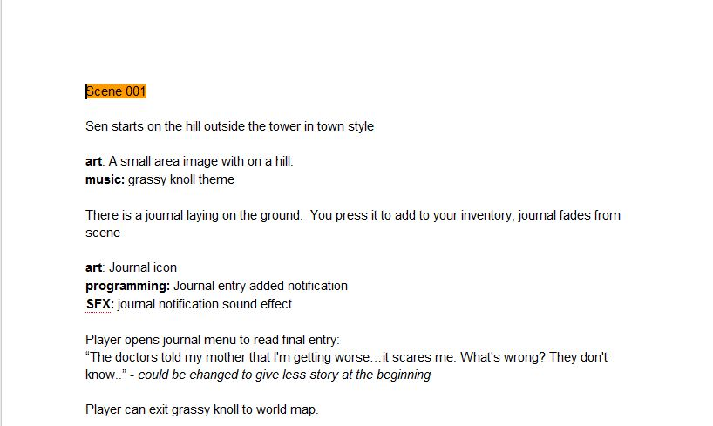

Figure Example of the storyline document

Quest sections are formatted in a different manner than scene sections. First and foremost, the section title is highlighted in green. The first item of information should be location, followed by a colon. Then come interaction and dialogue, also followed by a comma. Quest sections must have a completion requirement. After the completion requirement, a bulleted list of needs for quest development should follow. See the image below for reference.

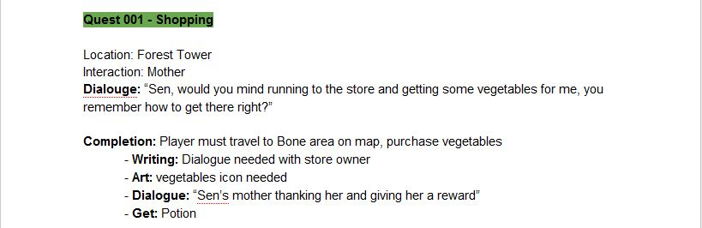

Figure Example of quest entry in the storyline document

### 10.3 Dialogue

Dialogue found in the storyline and quests documents should follow common dialogue rules. In the case of a specific character’s dialogue, state the character’s name, followed by a colon. After the colon, insert the dialogue text, with quotation marks and the beginning and the end (punctuation at the end of a sentence is placed *inside* the quotation marks). Be sure to capitalize the first word after the colon. Refer to the image below for an example of dialogue.

If the dialogue is longer than one paragraph, then there is a special rule for quotation marks. Every paragraph of dialogue must begin with a quotation mark. However, the only ending quotation mark should be placed at the end of the final paragraph.

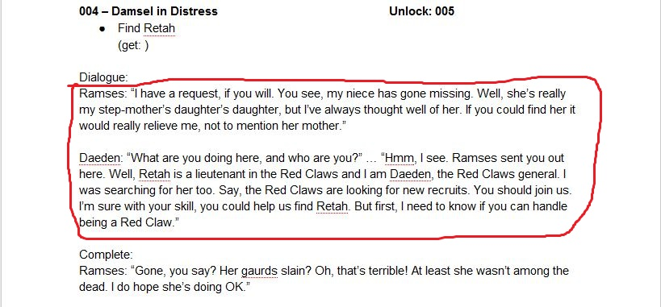

Figure Example of dialogue

## Planning Documents

### 11.1 Task List

The task list indicates progress on the *Monster Guru* project. The table is divided into many different categories. Do not create or delete categories unless express permission has been given to do so. Each task is broken up into task parts. As task parts are completed, they should be highlighted green and the completion text (DONE) entered into the *Expected Completion* column.

If possible, keep track of the actual amount of time required to complete each task part. Record this information in the Actual Time column. The Expected Time column is measured in hours and tells the reader how long completion for a particular task part is likely to take. Refer to the example below for more information.

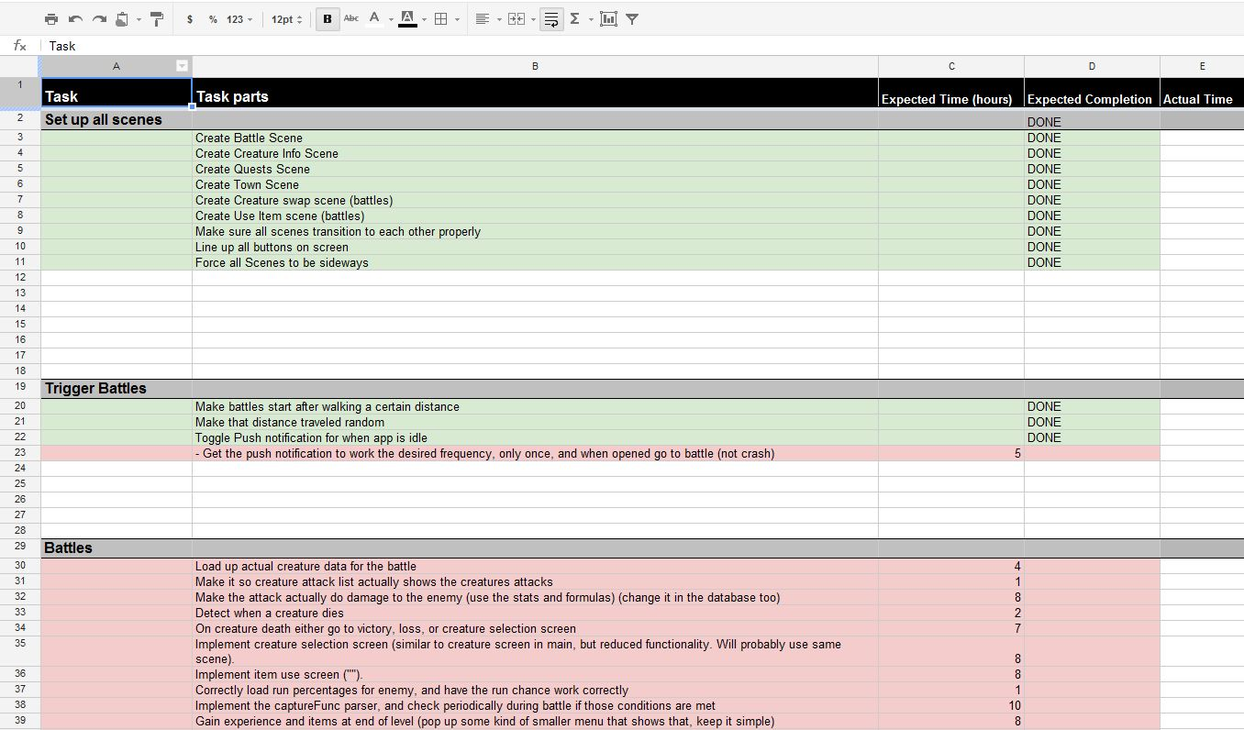

Figure Example of the Task List document

### 11.2 Art

The art in *Monster Guru* is a precious resource and the time of the artist is even more precious. As a result, the art table presents the various pieces of art that *Monster Guru* needs, so that the artist’s time is spent on relevant work.

The image below illustrates part of the art document. The table should consist of three columns (Art, Description, and Dimensions), and as many rows as are necessary. Each new row represents a different piece of art. The art table is color coded to represent the current state of art pieces. Color coding should only be updated by the artist or unless express permission is given.

The key contained within the document lays out the meaning of the color coding. Yellow indicates that the art piece is still needed. Light blue indicates that the art piece is finished. Green shows that the art piece is in the game and ready to go. Red tells the reader that there is a problem, a question, or some unresolved issue that needs to be taken care of before the art piece can be used in *Monster Guru*.

### C:\Users\Kyle\Desktop\Dropbox\Homework\Eng 3140\Style Guide Images\Art.JPG

Figure Example of the Art document